FEDERAL INSTITUTE OF SCIENCE AND TECHNOLOGY (FISAT)TM

**HORMIS NAGAR, MOOKKANNOOR**

**ANGAMALY-683577**



‘**FOCUS ON EXCELLENCE’**

**PYTHON PROGRAMMING**

…………………………………………………………………..

**LABORATORY RECORD**

**Name** : ABHIJITH RAJEEV

**Branch : MASTER OF COMPUTER APPLICATION**

**Semester : 1 Batch : SEMESTER -1** A

**Roll No : 1**

**FEDERAL INSTITUTE OF SCIENCE AND TECHNOLOGY (FISAT)TM**

**HORMIS NAGAR, MOOKKANNOOR**

**ANGAMALY-683577**



‘**FOCUS ON EXCELLENCE’**

**Name :** ABHIJITH RAJEEV

# Branch : MASTER OF COMPUTER APPLICATION

**Semester : 1 Roll No: 1**

**University Exam.Reg. No: FIT21MCA-2001**

**CERTIFICATE**

*This is to certify that this is a Bonafide record of the Practical work done and submitted to Kerala Technological University in partial fulfillment for the award of the Master Of Computer Applications is a record of the original research work done by ABHIJITH RAJEEV* *in the* ***PYTHON PROGRAMMING LAB*** *Laboratory of the Federal Institute of Science and Technology during the academic year 2020-2021.*

Signature of Staff in Charge Signature of H.O.D

Name: Name:

Date:

# Date of University practical examination ………………………

Signature of Signature of

Internal Examiner External Examiner

|  |  |  |  |  |
| --- | --- | --- | --- | --- |
| **CONTENTS** | | | | |
| **Sl.No** | **Date** | **Name of the Experiment** | **Page No** | **Signature of the Staff-**  **In-Charge** |
| 1 |  | Display future leap years from current  year to a final year entered by the user. | 1 |  |
| 2 |  | List comprehensions: | 2 |  |
| a |  | Generate positive list of numbers from a  given list of integers. | 2 |  |
| b |  | Square of N numbers | 3 |  |
| c |  | Form a list of vowels selected from a given word | 4 |  |
| d |  | List ordinal value of each element of a word | 5 |  |
| 3 |  | Count the occurrence of each word in a line of text. | 6 |  |
| 4 |  | Prompt the user for a list of integers. For all values greater than 100, store ‘over’ instead. | 7 |  |
| 5 |  | Store a list of first names. Count the occurrences of ‘a’ within the list | 8 |  |
| 6 |  | Enter 2 lists of integers. Check | 9 |  |
| a |  | Whether list are of same length*.* | 9 |  |
| b |  | Whether list sums to same value | 9 |  |
| c |  | Whether any value occur in both | 9 |  |
| 7 |  | Get a string from an input string where all occurrences of first character replaced  with ‘$’, except first character. | 11 |  |
| 8 |  | Create a string from given string where  first and last characters exchanged. | 12 |  |
| 9 |  | Accept the radius from user and find area of circle. | 13 |  |
| 10 |  | Find biggest of 3 numbers entered. | 14 |  |
| 11 |  | Accept a file name from user and print extension of that. | 15 |  |
|  | | | | |

|  |  |  |  |  |
| --- | --- | --- | --- | --- |
| 12 |  | Create a list of colors from comma- separated color names entered by user. Display first and last colors. | 16 |  |
| 13 |  | Accept an integer n and compute n+nn+nnn. | 17 |  |
| 14 |  | Print out all colors from color-list1 not contained in color-list2. | 18 |  |
| 15 |  | Create a single string separated with space from two strings by swapping the character at position 1. | 19 |  |
| 16 |  | Sort dictionary in ascending and descending order. | 20 |  |
| 17 |  | Merge two dictionaries. | 21 |  |
| 18 |  | Find gcd of 2 numbers. | 22 |  |
| 19 |  | From a list of integers, create a list removing even numbers. | 23 |  |
| 20 |  | Program to find the factorial of a number. | 24 |  |
| 21 |  | Generate Fibonacci series of N terms. | 25 |  |
| 22 |  | Find the sum of all items in a list. | 26 |  |
| 23 |  | Generate a list of four digit numbers in a given range with all their digits even and the number is a perfect square. | 27 |  |
| 24 |  | Display the given pyramid with step number accepted from user. | 28 |  |
| 25 |  | Count the number of characters (character frequency) in a string. | 29 |  |
| 26 |  | Add ‘ing’ at the end of a given string. If it already ends with ‘ing’, then add ‘ly’ | 30 |  |
| 27 |  | Accept a list of words and return length of longest word. | 31 |  |
| 28 |  | Construct pattern using nested loop | 32 |  |
| 29 |  | Generate all factors of a number. | 33 |  |
| 30 |  | Write lambda functions to find area of square, rectangle and triangle. | 34 |  |
| 31 |  | Work with built-in packages. | 35 |  |
|  | | | | |

|  |  |  |  |  |
| --- | --- | --- | --- | --- |
| 32 |  | Create a package graphics with modules rectangle,circle.include method to find area and perimeter of respective figures in each.Write a program to find area and perimeter of figure by different importing  statements. | 36 |  |
| 33 |  | Create Rectangle class with attribute length and breadth and methods to find  area and perimeter. Compare 2 Rectangle objects with their area. | 37 |  |
| 34 |  | Create a Bank account with members account number, name, type of account and balance. Write constructor and methods to deposit at the bank and  withdraw an amount from the bank | 38 |  |
| 35 |  | Create a class Rectangle with private attributes length and width. Overload ‘<’ operator to compare the area of 2 rectangles. | 39 |  |
| 36 |  | Create a class Time with private attributes hour, minute and second. Overload ‘+’ operator to find sum of time | 40 |  |
| 37 |  | Create a class Publisher(name). Derive class Book from Publisher with attributes title and author. Derive class Python from Book with attributes and no of pages. Write a program that displays information about a Python book. Use  base class constructor and method overriding. | 41 |  |
| 38 |  | Write a Python program to read a file line  by line and store it into a list. | 42 |  |
| 39 |  | Python program to copy odd lines of one file to other. | 43 |  |
|  | | | | |

***Department of MCA Expt No:*** *..............*

# Display future leap years from current year to a final year entered by user.

**Program:**

print("Leap Years") print(" ")

start=int(input("enter starting year: ")) end=int(input("enter ending year: ")) c=0

print("Leap years in between" ,start ,"and",end,"are") while start <= end :

if start % 4 == 0 and start % 100 !=0 : print(start)

c+=1

if start % 100 == 0 and start % 400 == 0 : print(start)

start = start+1

print("number of leap years is: ",c)

**Output:**

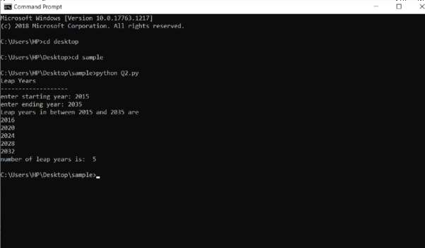

## Federal Institute of Science and Technology (FISAT) TM

Page | 1

***Department of MCA Expt No:*** *..............*

# List comprehensions

1. **Generate positive list of numbers from a given list of integers. Program:**

print("postive integers from a list")

print(" ") list1=[9,-2,0,42,75,-33]

for num in list1: if num >=0 :

print(num,end=" ")

**Output:**

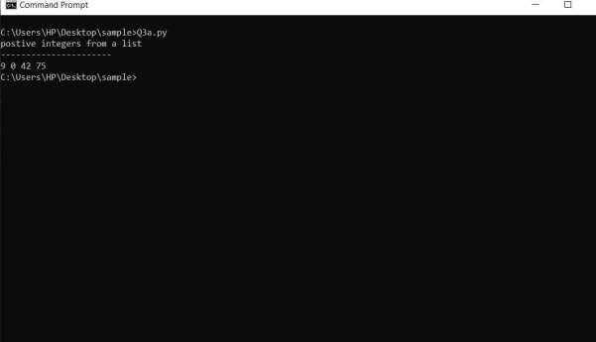

## Federal Institute of Science and Technology (FISAT) TM

Page | 2

***Department of MCA Expt No:*** *..............*

# Square of N numbers.

**Program:**

print("Square of N numbers") print(" ") limit=int(input("enter limit: ")) list1=[]

for i in range(1,limit+1): list1.append(i*i) print(list1)

**Output:**

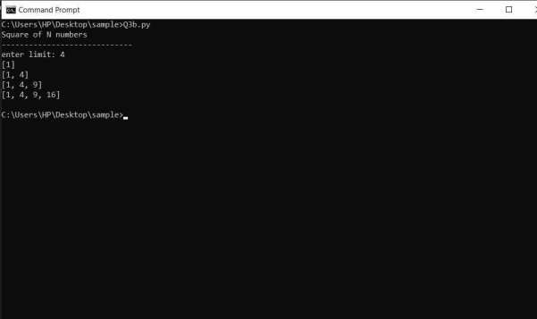

## Federal Institute of Science and Technology (FISAT) TM

Page | 3

***Department of MCA Expt No:*** *..............*

# Form a list of vowels selected from a given word. Program:

print("Ordinal values") print(" ")

str=input("enter a word:") vowels=0

for char in str :

if char in 'aeiouAEIOU' : vowels=vowels+1

else :

continue print(vowels)

**Output:**

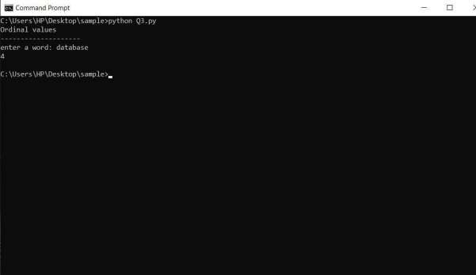

## Federal Institute of Science and Technology (FISAT) TM

Page | 4

***Department of MCA Expt No:*** *..............*

# List of ordinal values of each element of a word Program:

print("Ordinal value") print(" ") word=input("enter a word: ") for ch in word:

print("Ordinal value of "+ch+" is ",ord(ch))

# Output :

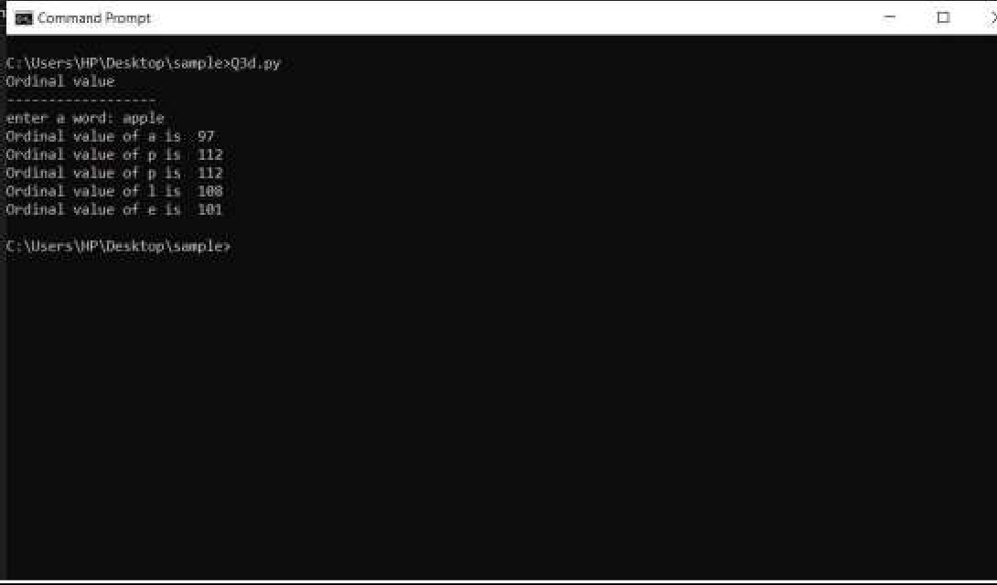

## Federal Institute of Science and Technology (FISAT) TM

Page | 5

***Department of MCA Expt No:*** *..............*

# Count the occurrences of each word in a line of text. Program:

print("occurence of eachword") print(" ")

str=input("enter a text: ") counts={} words=str.split()

for word in words : if word in counts : counts[word]+=1

else : counts[word]=1

for k,v in counts.items(): print(k,v)

**Output:**

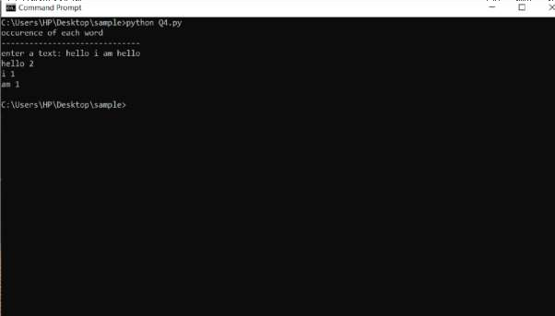

## Federal Institute of Science and Technology (FISAT) TM

Page | 6

***Department of MCA Expt No:*** *..............*

# Prompt the user for a list of integers. For all values greater than 100, store ‘over’ instead.

**Program:**

list=[45,102,20,120]

new_list=[] for i in list:

if i>100:

new_list.append("over") else:

new_list.append(i) print(new_list)

**Output:**

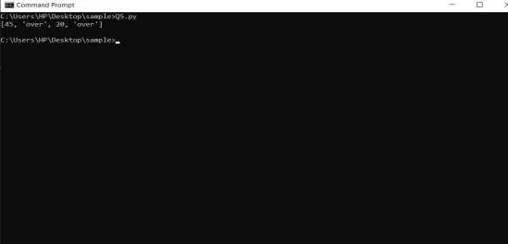

## Federal Institute of Science and Technology (FISAT) TM

Page | 7

***Department of MCA Expt No:*** *..............*

# Store a list of first names. Count the occurrences of ‘a’ within the list. Program:

list=input("enter names: ") words=list.split() print(words)

c=0

for word in words : for char in word : if char in 'a' : c=c+1

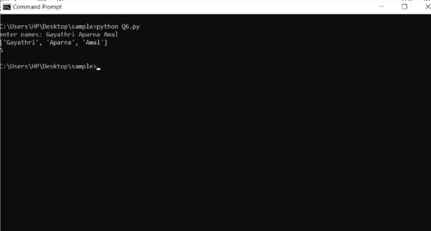else : continue print(c) **Output:**

## Federal Institute of Science and Technology (FISAT) TM

Page | 8

***Department of MCA Expt No:*** *..............*

# Enter 2 list of integers. Check (a) Whether lists are of same length (b) Whether lists sums to same value (c) Whether any value occur in both

**Program:**

print("list of integers") print(" ") list1=[1,23,34,26] list2=[1,56,39,2,67]

if len(list1)==len(list2): print("lists are of samelength") else :

print("different length")

if sum(list1)==sum(list2) : print("Sum is same")

else :

print("Sum isdifferent") f=0

for elem in list2 : if elem in list1 : f=1

if f==1 : print(‘True’) else : print(False)

## Federal Institute of Science and Technology (FISAT) TM

Page | 9

***Department of MCA Expt No:*** *..............*

**Output:**

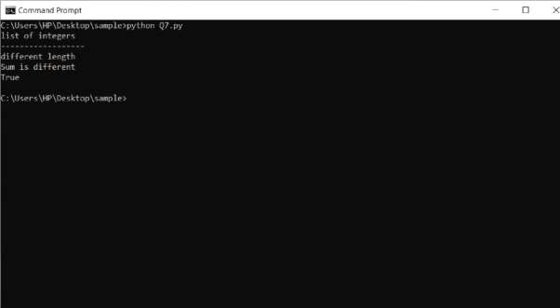

## Federal Institute of Science and Technology (FISAT) TM

Page | 10

***Department of MCA Expt No:*** *..............*

# Get a string from an input string where all occurrences of first character replaced with ‘$’, except first character.

**Program:**

str=input("enter a string: ") first_letter=str[0] replace_str="$"

new_str=str.replace(first_letter,replace_str) print(new_str.replace(replace_str,first_letter,1))

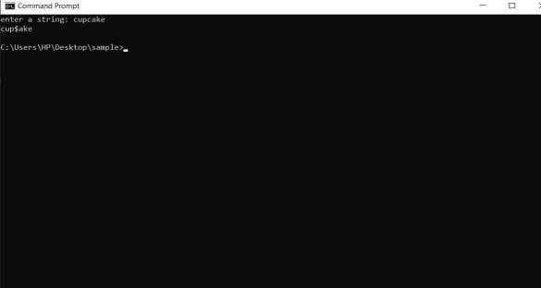**Output:**

\

## Federal Institute of Science and Technology (FISAT) TM

Page | 11

***Department of MCA Expt No:*** *..............*

# Create a string from given string where first and last characters exchanged. Program:

str=input("Enter string: ") letters=list()

for i in str: letters.append(i) first_letter=letters[0] letters[0]=letters[-1] letters[-1]=first_letter rev_str=" " print(rev_str.join(letters))

# Output:

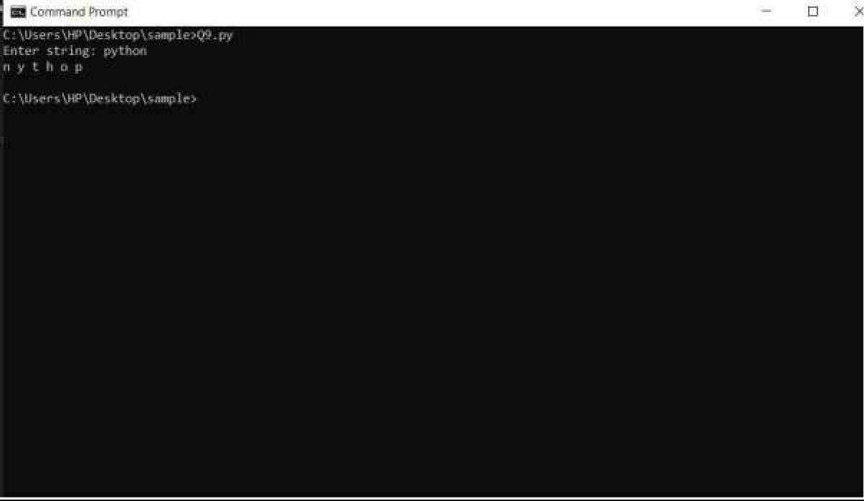

## Federal Institute of Science and Technology (FISAT) TM

Page | 12

***Department of MCA Expt No:*** *..............*

# Accept the radius from user and find area of circle. Program:

print("area of a circle") r=float(input("enter radius of thecircle:")) area=3.14*r*r

print("area= ",area)

**Output:**

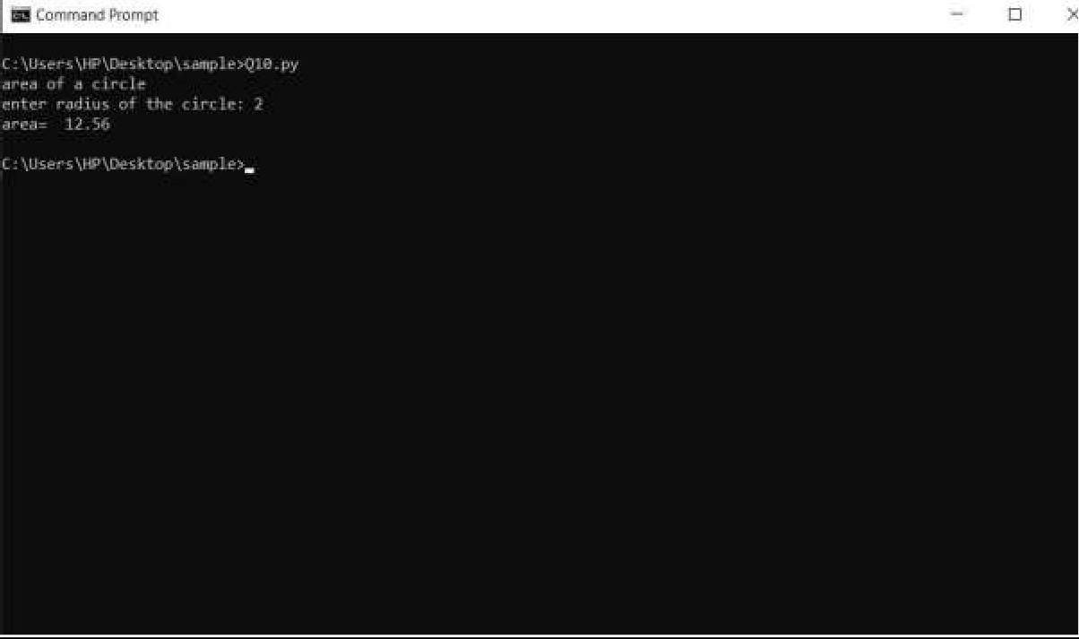

.

## Federal Institute of Science and Technology (FISAT) TM

Page | 13

***Department of MCA Expt No:*** *..............*

# Find the biggest of 3 numbers entered. Program:

print("Largest of 3 numbers") print(" ")

n1=int(input("Enter first number: ")) n2=int(input("Enter second number: ")) n3=int(input("Enter third number: "))

if (n1>=n2) and (n1>=n3): largest=n1

elif (n2>=n1)and(n2>=n3): largest=n2

else :

largest=n3

print("Largest number is: ",largest)

**Output:**

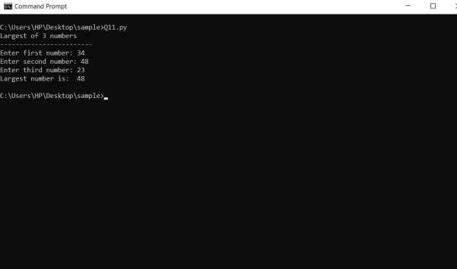

## Federal Institute of Science and Technology (FISAT) TM

Page | 14

***Department of MCA Expt No:*** *..............*

# Accept a file name from user and print extension of that. Program:

print("Extension of file") print(" ") file=input("enter file name: ") l=list()

l=file.split(".")

print(l[-1])

**Output:**

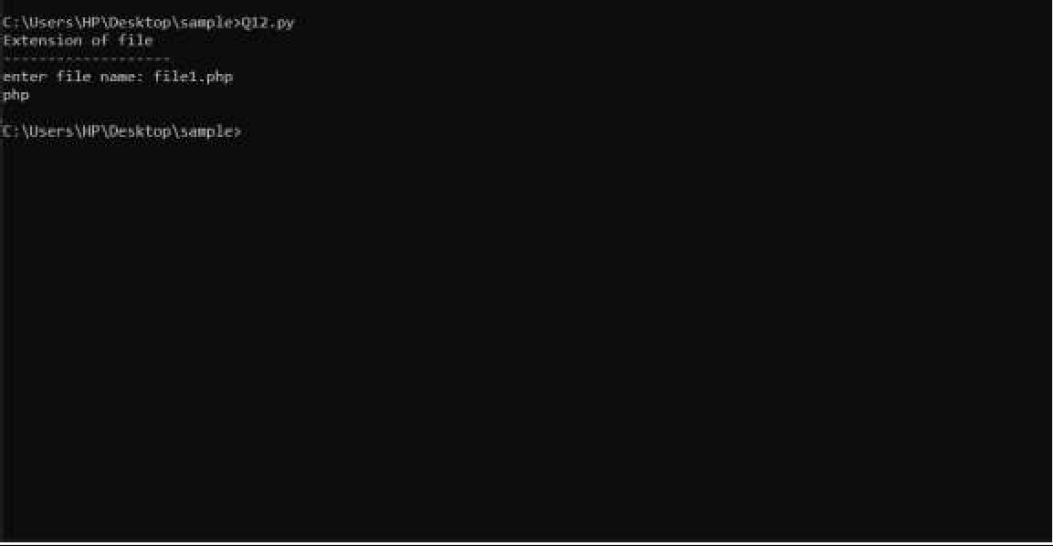

## Federal Institute of Science and Technology (FISAT) TM

Page | 15

***Department of MCA Expt No:*** *..............*

# Create a list of colors from comma-separated color names entered by user. Display first and last colors.

**Program:**

List1=['blue','black','yellow','red','white'] print("first color",:List1[0])

print("last color: ",List1[4])

**Output:**

## Federal Institute of Science and Technology (FISAT) TM

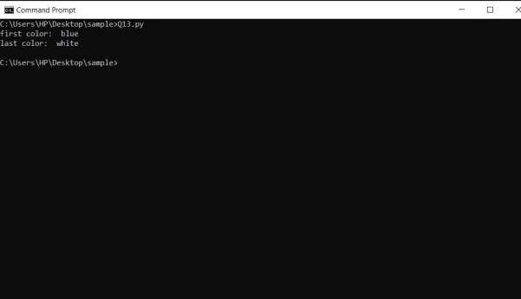

Page | 16

***Department of MCA Expt No:*** *..............*

# Accept an integer n and compute n+nn+nnn. Program: :

n=int(input("Enter number: "))

num=n

+ n * n + n * n * n

print(num)

**Output:**

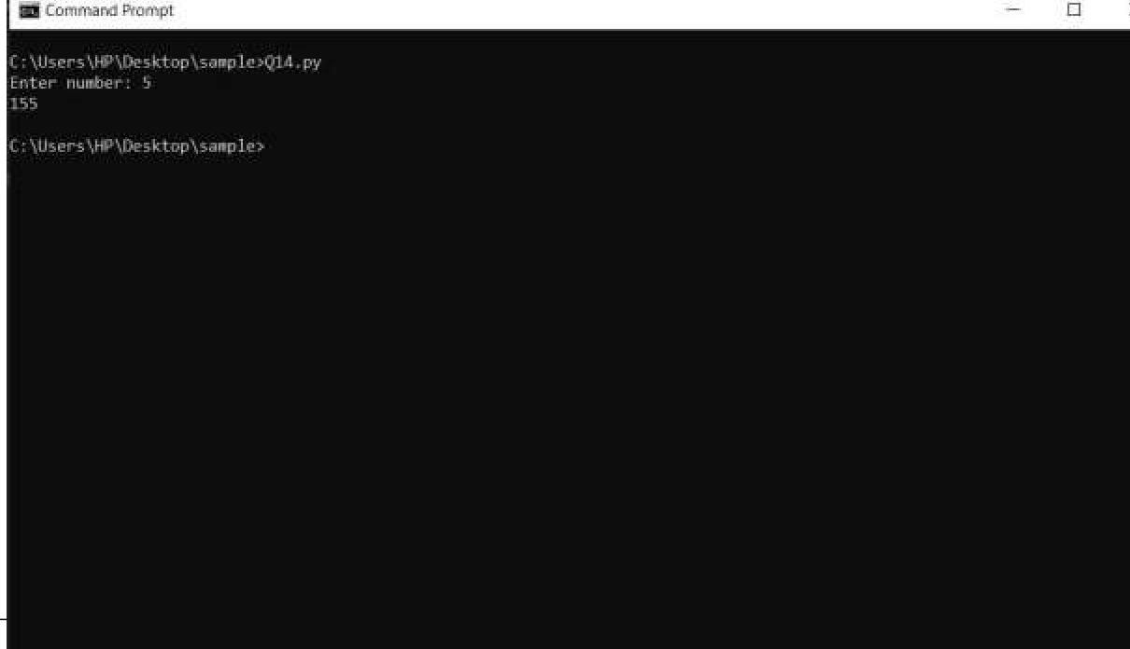

## Federal Institute of Science and Technology (FISAT) TM

Page | 17

***Department of MCA Expt No:*** *..............*

# 14 .Print out all colors from color-list1 not contained in color-list2. Program:

color_list1=['blue','white','black','green','indigo'] color_list2=['green','red','blue','white','yellow'] sorted_list=list(set(color_list1) - set(color_list2))

print("colors are: ",sorted_list)

**Output:**

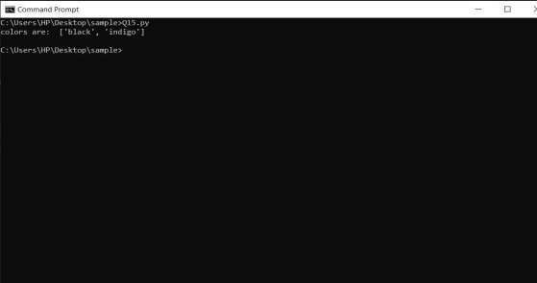

## Federal Institute of Science and Technology (FISAT) TM

Page | 18

***Department of MCA Expt No:*** *..............*

# Create a single string separated with space from two strings by swapping the character at position 1.

**Program:**

str1=input("enter first string: ") str2=input("enter second string: ") new_str1=str2[:1] + str1[1:] new_str2=str1[:1] + str2[1:]

print("After swapping: ",new_str1 + ' ' + new_str2)

**Output:**

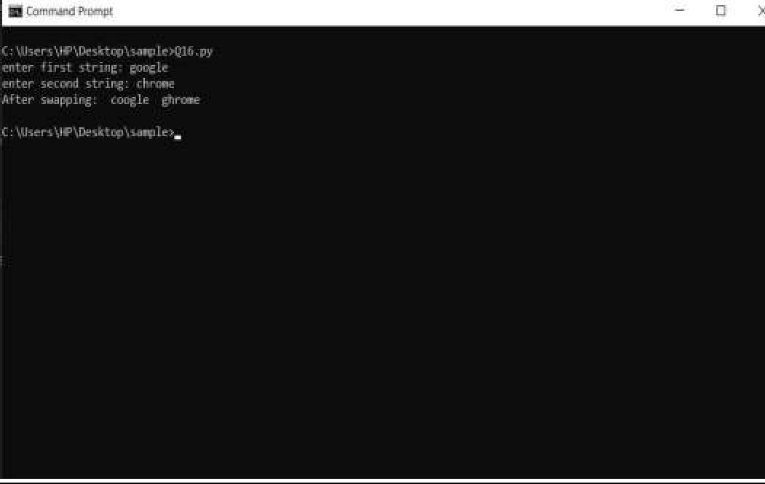

## Federal Institute of Science and Technology (FISAT) TM

Page | 19

***Department of MCA Expt No:*** *..............*

# Sort dictionary in ascending and descending order. Program:

print("Dictonary sorting") print(" ")

D={'alan':12,'susan':75,'elizabeth':30,'joe':32} print("Original dictionary is: ",D) l=list(D.items())

l.sort()

print("Ascending order is: ",l) l=list(D.items()) l.sort(reverse=True)

print("Descending order is: ",l)

**Output:**

. .

## Federal Institute of Science and Technology (FISAT) TM

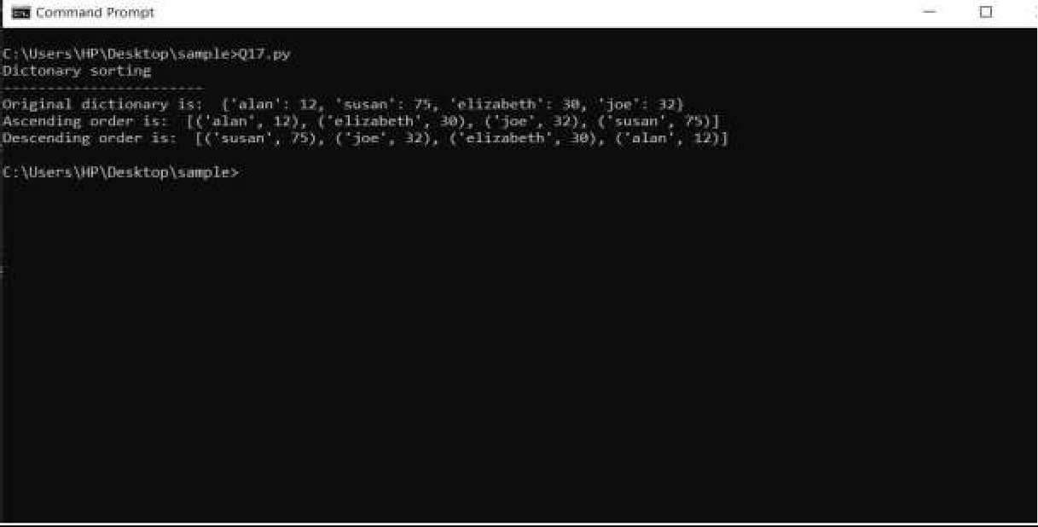

Page | 20

***Department of MCA Expt No:*** *..............*

1. **Merge two dictionaries Program:** print("Dictionarymerging") print(" ") d1={'a':10,'b':8,'c':6,'d':4} d2={'m':5,'n':3,'o':2,'p':1} print('Before merging\n') print("Dictonary 1: ",d1) print("Dictonary 2: ",d2) d1.update(d2)

print('After merging\n',d1)

**Output:**

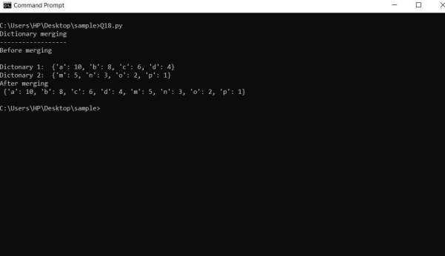

## Federal Institute of Science and Technology (FISAT) TM

Page | 21

***Department of MCA Expt No:*** *..............*

# Find gcd of 2 numbers. Program:

print("GCD of 2 numbers") print(" ")

n1=int(input("enter first number: ")) n2=int(input("enter second number: ")) def gcd(a,b):

if(b==0):

return a else:

return gcd(b,a%b) result=gcd(n1,n2)

print("Gcd of" ,n1, "and" ,n2, "is:",result)

**Output:**

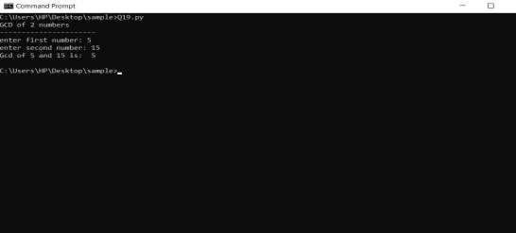

## Federal Institute of Science and Technology (FISAT) TM

Page | 22

***Department of MCA Expt No:*** *..............*

# From a list of integers, create a list removing even numbers. Program:

limit=int(input("enter limit: ")) n=[]

for i in range(1,limit+1): num=int(input(f"enter the {i} th number:")) n.append(num)

print("entered list: ",n) odd_list=[]

for i in n:

if i%2!=0:

odd_list.append(i)

print("list after removing even numbers",odd_list)

**Output:**

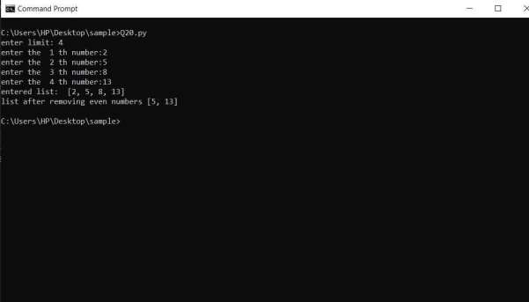

## Federal Institute of Science and Technology (FISAT) TM

Page | 23

***Department of MCA Expt No:*** *..............*

# Program to find the factorial of a number Program:

print("factorial of a number") print(" ") num=int(input("enter a number: ")) fact=1

if num < 0:

print("enter a positive number") else:

for i in range(1,num+1): fact=fact*i

print("factorial of",num,"is",fact)

**Output:**

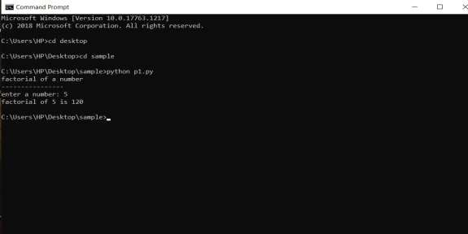

## Federal Institute of Science and Technology (FISAT) TM

Page | 24

***Department of MCA Expt No:*** *..............*

# Generate Fibonacci series of N terms

**Program:**

print("fibonacci series") print(" ") limit=int(input("enter limit: ")) n1=0

n2=1

count=1

while count < limit: print(n1)

n=n1+n2 n1=n2 n2=n

count=count+1

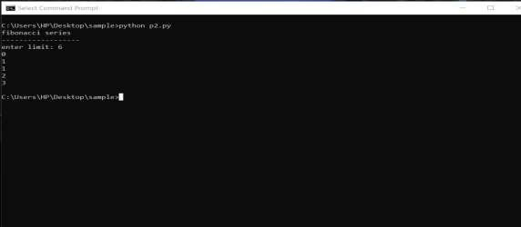**Output:**

## Federal Institute of Science and Technology (FISAT) TM

Page | 25

***Department of MCA Expt No:*** *..............*

# Find the sum of all items in a list Program:

print("sum of all items")

print(" ") total=0 list1=[11,10,12,20,5] for ele in range(0,len(list1)):

total = total + list1[ele]

print("sum of all items in the list: ",total)

**Output:**

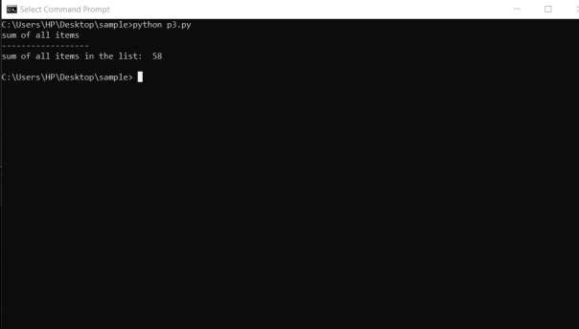

## Federal Institute of Science and Technology (FISAT) TM

Page | 26

***Department of MCA Expt No:*** *..............*

# Generate a list of four digit numbers in a given range with all their digits even and the number is a perfect square.

**Program:**

sq_list=[]

limit=int(input("enter the range: ")) if(limit<1000 or limit>9999):

print("enter a range between 1000 to 9999") else:

for i in range(32,99):

s=0 if(i*i>limit):

break else:

for k in str(i*i):

if(int(k)%2==0):

s=s+1 if(s==4):

sq_list.append(i*i) if(len(sq_list)==0):

print("No numbers satisfying both conditions found in the range") else:

print(f"Numbers satisfying both conditons are->{sq_list}")

**Output:**

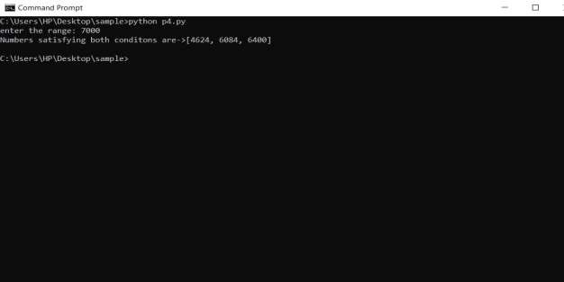

## Federal Institute of Science and Technology (FISAT) TM

Page | 27

***Department of MCA Expt No:*** *..............*

# Display the given pyramid with step number accepted from user. Eg: N=4

**1**

**2 4**

**3 6 9**

**4 8 12 16**

**Program:**

sum=0

limit=int(input("enter limit:")) for i in range(1,limit+1): print("\n")

for j in range(1,i+1): sum=i*j print(sum,end=' ') print("\n")

**Output :**

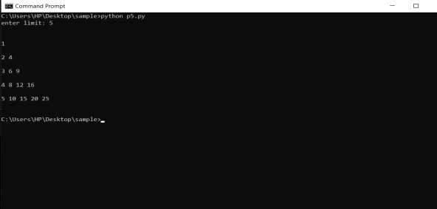

## Federal Institute of Science and Technology (FISAT) TM

Page | 28

***Department of MCA Expt No:*** *..............*

# Count the number of characters (character frequency) in a string. Program:

print("Number of characters in a string") print(" ") string=input("enter a string: ")

count=0

for i in range(0,len(string)):

if(string[i]!=' '):

count = count + 1

print("Total numbers of characters in the string : "+str(count))

**Output:**

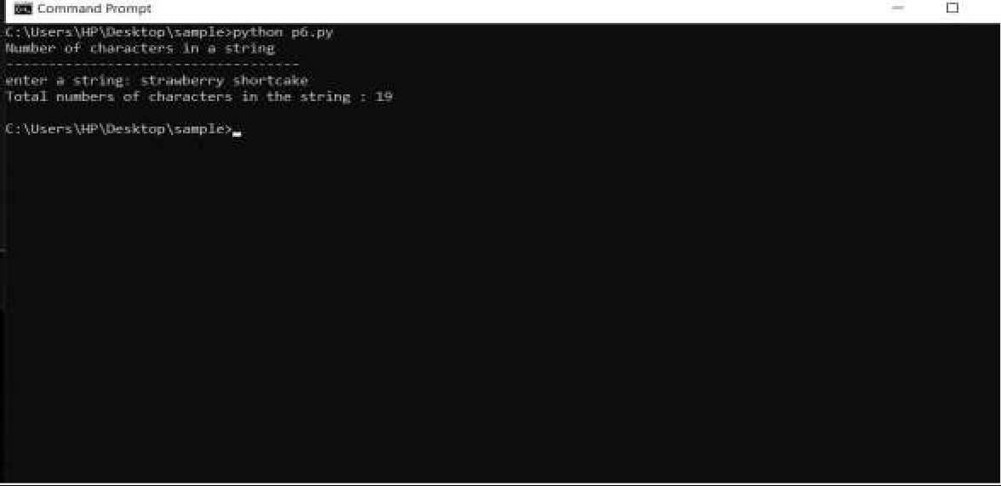

## Federal Institute of Science and Technology (FISAT) TM

Page | 29

***Department of MCA Expt No:*** *..............*

# Add ‘ing’ at the end of a given string. If it already ends with ‘ing’, then add ‘ly’. Program:

string1=input("enter a string: ") str1="ly"

str2="ing" last=string1[-3:] if last in 'ing':

string1=string1+str1 print("string is: "+string1) else:

string1=string1+str2 print("string is: "+string1)

**Output:**

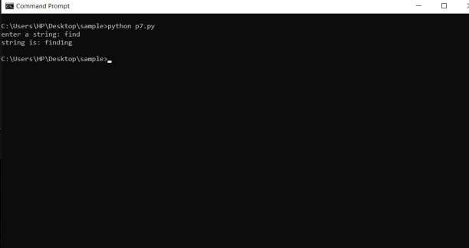

## Federal Institute of Science and Technology (FISAT) TM

Page | 30

***Department of MCA Expt No:*** *..............*

# Accept a list of words and return length of longest word. Program:

str_list=list() long=0 string=' '

lim=int(input("enter the limit: ")) for i in range(1,lim+1):

item=str(input(f"enter the string{i}:"))

str_list.append(item) for i in str_list:

if(long<=len(i)):

long=len(i) string=i

print(f"Longest word in the list is {string} and its length is {long}")

**Output:**

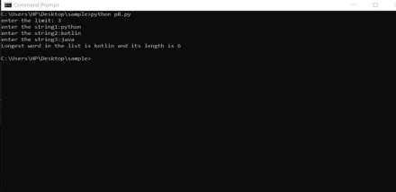

## Federal Institute of Science and Technology (FISAT) TM

Page | 31

***Department of MCA Expt No:*** *..............*

# Construct following pattern using nested loop.

*

* *

* * *

* * * *

* * * * *

* * * *

* * *

* *

*

**Program:**

lim=int(input("enter the limit: ")) print("\n")

for i in range(1,lim+1): print('*'*i)

j=lim-1 while(j!=0):

print('*'*j) j=j-1

**Output:**

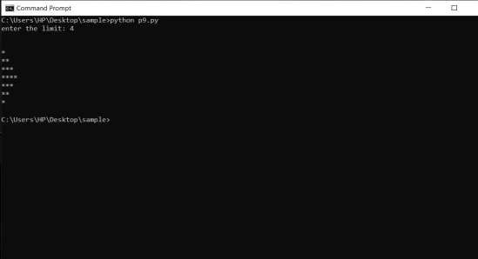

## Federal Institute of Science and Technology (FISAT) TM

Page | 32

***Department of MCA Expt No:*** *..............*

# Generate all factors of a number. Program:

print("factors of a number")

print(" ") num=int(input("enter a number: ")) print("factors are: ")

for i in range(1,num+1): if num % i ==0:

print(i)

**Output:**

## Federal Institute of Science and Technology (FISAT) TM

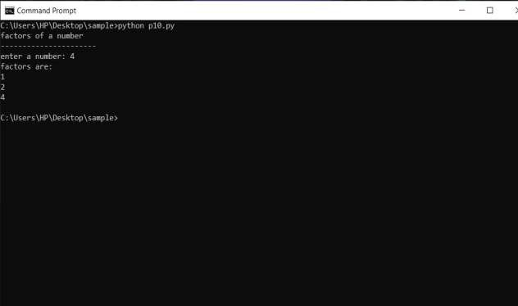

Page | 33

***Department of MCA Expt No:*** *..............*

# Write lambda functions to find area of square, rectangle and triangle. Program:

square=lambda x: x ** 2 rectangle=lambda x,y: x*y triangle=lambda x,y: 0.5*(x*y) print("1.Area of square") print("2.Area of rectangle") print("3.Area of triangle") print("\n")

ch=int(input("enter a choice: ")) if(ch==1):

side = int(input("enter one side: ")) print("\n")

print(f"Area of the square is {square(side)}") elif(ch==2):

length=int(input("enter the length: ")) breadth=int(input("enter the breadth: ")) print("\n")

print(f"Area of the rectangle is{rectangle(length,breadth)}") elif(ch==3):

height=int(input("enter the height: ")) breadth=int(input("enter the breadth: ")) print("\n")

print(f"Area of triangle is{int(triangle(height,breadth))}") else:

print("Invalid input")

**Output:**

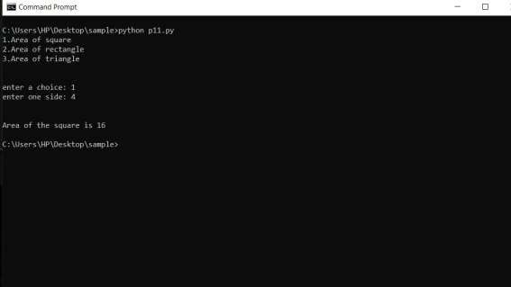

## Federal Institute of Science and Technology (FISAT) TM

Page | 34

***Department of MCA Expt No:*** *..............*

# Work with built-in packages Program:

import time import datetime

today=datetime.date.today()

print(f"The time is {time.ctime()} and date is {today}")

**Output:**

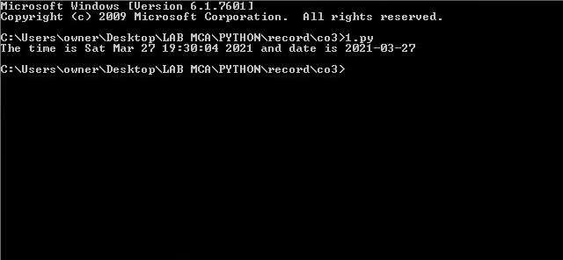

## Federal Institute of Science and Technology (FISAT) TM

Page | 35

***Department of MCA Expt No:*** *..............*

# Create a package graphics with modules rectangle,circle.include method to find area and perimeter of respective figures in each.Write a program to find area and perimeter of figure by different importing statements

**Program:**

from graphics import rectangle as r, circle as c

from graphics.three_d_graphics import sphere as s, cuboid as cu print(f"Area of rectangle :{r.area(12,12)}")

print(f"Area of circle :{c.area(6)}") print(f"Area of sphere :{s.area(12)}") print(f"Area of cuboid :{cu.area(12,16,18)}")

print(f"Perimeter of rectangle :{r.perimeter(12,12)}") print(f"Perimeter of circle :{c.perimeter(6)}") print(f"Diameter of sphere :{s.diameter(12)}") print(f"Periameter of cuboid :{cu.perimeter(12,16,18)}") **Output:**

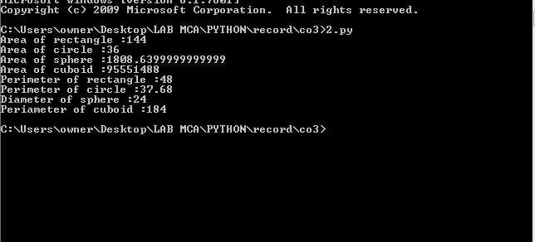

## Federal Institute of Science and Technology (FISAT) TM

Page | 36

***Department of MCA Expt No:*** *..............*

# Create Rectangle class with attributes length and breadth and methods to find area and perimeter. Compare two Rectangle objects by their area.

**Program:**

class Rectangle:

def arearect(self,l,w): self.l=l

self.w=w self.area=self.l*self.w print("area= ",self.area)

rect1=Rectangle() rect2=Rectangle() rect1.arearect(11,7) rect2.arearect(9,7) if(rect1.area<rect2.area):

print("rectangle 2 is having greater area") elif(rect1.area==rect2.area):

print("both rectangles have some area") else:

print("rectangle 1 is having greater area")

**Output:**

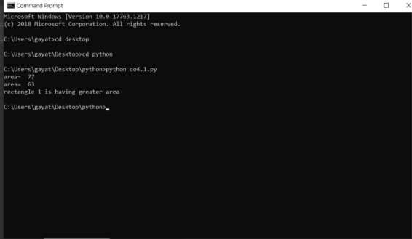

## Federal Institute of Science and Technology (FISAT) TM

Page | 37

***Department of MCA Expt No:*** *..............*

# Create a Bank account with members account number, name, type of account and balance. Write constructor and methods to deposit at the bank and withdraw an amount from the bank.

**Program:**

class Bank_account:

def init (self,acc_no,name,acc_type,balance): self.acc_no=acc_no

self.name=name self.acc_type=acc_type self.balance=balance

def deposit(self,deposit_am):

print("Initial balance: ",self.balance) print("Amount to be deposited: ",deposit_am) self.balance=self.balance+deposit_am print("New balance is: ",self.balance)

def withdraw(self,withdrawn_am): print("current balance: ",self.balance)

print("amount_withdrawn: ",withdrawn_am) self.balance=self.balance-withdrawn_am print("New balance is: ",self.balance)

P=Bank_account(1234,'Rose','savings',75000) P.deposit(24000)

P.withdraw(36000)

**Output:**

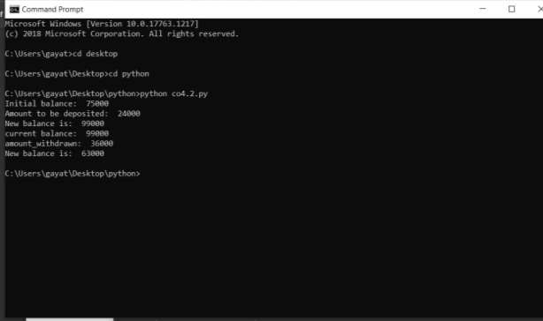

## Federal Institute of Science and Technology (FISAT) TM

Page | 38

***Department of MCA Expt No:*** *..............*

# Create a class Rectangle with private attributes length and width. Overload ‘<’ operator to compare the area of 2 rectangles.

**Program:**

class Rectangle:

def init (self,l,w):

self.l=l self.w=w

def lt (self,a):

if((self.l*self.w)>(a.l*a.w)):

print("rect1 is having greater area") return(self.l*self.w)

else:

rect1=Rectangle(9,4) rect2=Rectangle(8,5) print(rect1<rect2)

**Output:**

print("rect2 is having greater area") return(a.l*a.w)

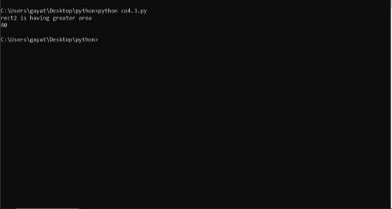

## Federal Institute of Science and Technology (FISAT) TM

Page | 39

***Department of MCA Expt No:*** *..............*

# 36 .Create a class Time with private attributes hour, minute and second. Overload ‘+’ operator to find sum of 2 time.

**Program:**

class Time:

def init (self,hr,min,sec):

self.hr=hr self.min=min self.sec=sec

def add (self,t):

return(self.hr+t.hr,self.min+t.min,self.sec+t.sec) t1=Time(4,15,45)

t2=Time(5,45,30)

print(t1+t2)

**Output:**

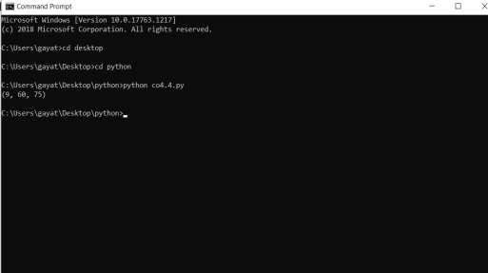

## Federal Institute of Science and Technology (FISAT) TM

Page | 40

***Department of MCA Expt No:*** *..............*

# Create a class Publisher (name). Derive class Book from Publisher with attributes title and author. Derive class Python from Book with attributes price and no_of_pages. Write a program that displays information about a Python book. Use base class constructor invocation and method overriding.

**Program:**

class Publisher:

def init (self,n):

self.name=n class Book(Publisher):

def init (self,n,a,t):

super(). init (n) self.title=t self.author=a

class Python(Book):

def init (self,n,a,t,p,pg): super(). init (n,a,t) self.price=p self.pages=pg

def Print(self):

print(P.name) print(P.title) print(P.author) print(P.price) print(P.pages)

P=Python('dcbooks','programming','mark',500,200) P.Print()

**Output:**

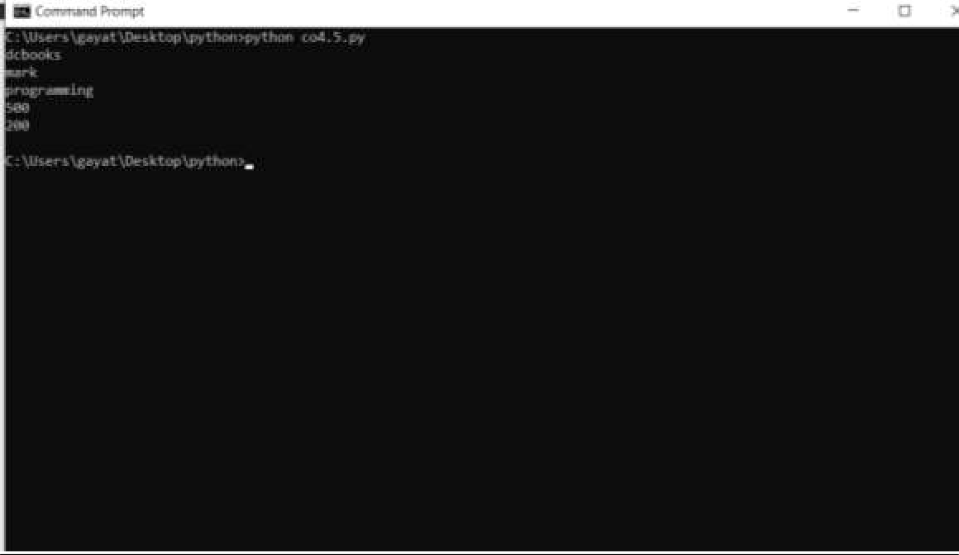

## Federal Institute of Science and Technology (FISAT) TM

Page | 41

***Department of MCA Expt No:*** *..............*

# Write a Python program to read a file line by line and store it into a list Program:

file1=open("demofile1.txt",'r')

list1=file1.readlines()

print(f"After storing to list:\n{list1}")

**Output:**

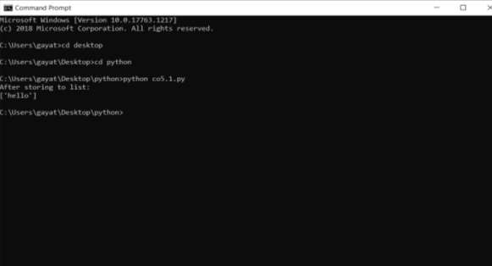

## Federal Institute of Science and Technology (FISAT) TM

Page | 42

***Department of MCA Expt No:*** *..............*

# Python program to copy odd lines of one file to other Program:

file1=open("demofile1.txt",'r')

file2=open("demofile2.txt",'w+') list1=file1.readlines()

for i in range(0,len(list1),2): file2.write(list1[i])

print("odd lines copied to another file")

**Output:**

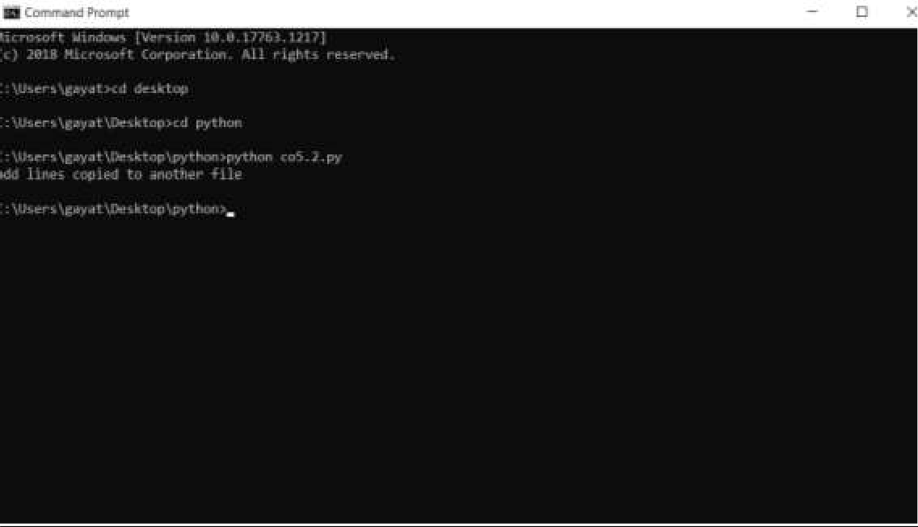

## Federal Institute of Science and Technology (FISAT) TM

Page | 43